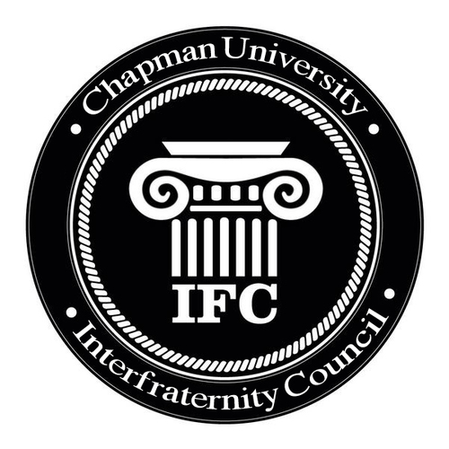
Chapman Interfraternity Council Agenda
1/30/18
President:
Welcome!
Introduction
Voting: Lowering Rush fee, adding additional info to the rush bi-laws
Do we want tabling?
Ideas: Bring up GPA on campus, don’t want to raise the rush GPA?
Exec Retreat Info: Feb.11th, 10AM-2PM
Ideas for advertising Rush?

Vice President:
- Check your Facebook, Accept my friend request please
- Vote: Lowering of Rush Fee to $10
- Vote: Will tabling be allowed or not during the pre-rush period*
- Vote: Rush events must be disclosed and calendared prior to the outset of rush in order to be considered legitimate rush events*

